Government of Montenegro
The Bureau for Education Services

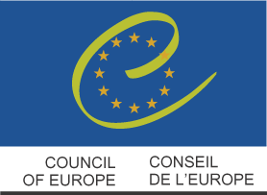

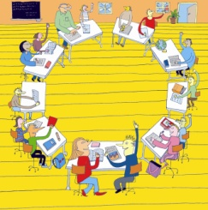
Human Rights in Action
Action Plan 2016
Project title: Let's do it together

School: Primary school Barilović
Authors:
Ivana Banjavčić, Josip Novosel, Vesna Car i Dejana Kirinčić
Date: 24.08.2016.
Version: 2

Describe the area/s (teaching and learning, governance, partnership) and the problem you would like to address in one or two sentences

Community links and partnerships – partnership with parents and local community promote EDC/HRE
Lack of communication between parents, teachers, students.

Expected outcomes:

- School staff cooperates with parents and local community to promote EDC/HR.
- Participation of parents in organization of school project.
- Our school is partnering with other schools in Europe to promote EDC/HR

Target group/s:

- parents
- students
- teachers

Partners:

- NGO
- Partner schools

Competences for Democratic Culture addressed:

- Values | - Valuing democracy  - Valuing cultural diversity  - Valuing human dignity and human rights
- Skills | - Cooperation skills  - Skills of listening and observing  - Empathy
- Attitudes | - Civic-mindedness  - Openness to cultural otherness and to other beliefs, world views and practices  - Respect  - Responsibility  - Self-efficacy
- Knowledge and critical  - understanding | - Knowledge and critical understanding of language and communication  - Knowledge and critical understanding of the self  - Knowledge and critical understanding of the world
Brief description of the activities
- ( e.g. meeting, research, presentation, workshop, lesson etc.)

Start date:
ACTIVITY | TARTGET GROUP | RISK FACTORS  and what can you do? | DATE/DEADLINE
Presentation of the Action Plan and the objectives of the project to Councils of the school | Teachers  Parents  Students | Lack of interest and time | September
Teachers plan lessons and workshops on EDC/HR for the Annual plan and program of school | Teachers  Students | Unwillingness of some teachers to change their plans and methods | September
The Action plan is included in School Curriculum and Annual plan and program of school | Teachers  Parents | No risk | September
Establish the Team for Human Rights | Teachers  Parents  Students | No risk | October
Workshops on EDC/HR in class councils and parents meetings | Parents  Students | Lack of interest | October - March
Project on EDC/HR with partner school | Students  Teachers | Finding a partner who wants to cooperate | October - May
Exchange of experience and examples of good practice | Partner school, teachers, parents and students | Technical condition | April
Project day | Teachers and parents | Technical and financial conditions | May
Survey for students, parents and teachers | Students  Parents  Teachers | Frequent tests | May
Presentation of the results in public using local and other media | Students  Parents  Teachers | No risk | May

Final evaluation:

- How will you know that you achieved the expected outcomes

We increased number of meetings with Parents council.
Parents communicate more with school and they organizing Project day together with teachers.
Project organized with partner school.
Survey for students, parents and teachers.

