MAGIC SQUARE
The magic square is a square table in which we enter the given numbers so that in each row, each column and on each diagonal the sum of the entered numbers is equal. We call this number a magic sum.

Example: A magic square of 3x3 fields. The sum in each row, column or diagonal is the same number. In this case it is number 15.
15

15

15

15

2 | 7 | 6
9 | 5 | 1
4 | 3 | 8
15 15 15 15

Task: Your magic square has 4x4 fields. The numbers entered in it are: 3, 8, 9 and 14.
In front of you are cards with other numbers (1, 2, 3, 5, 6, 7, 8, 9, 10, 11, 12, 13, 14, 15 and 16). Take scissors and cut out the number cards first. Then arrange the numbers in a square so that in each row, column or diagonal the sum is 34.
3
8
9
14

YOU NEED TO PREPARE A MAGIC SQUARE (as in the picture) and number cards
(1, 2, 3, 5, 6, 7, 8, 9, 10, 11, 12, 13, 14, 15 i 16).

2. There are glasses of yogurt on the table. A number (multiplication) is written on each glass. There are lids on the table. Calculate the product on each lid. Then pair the glass and lid. One cover has no match. Find which one?
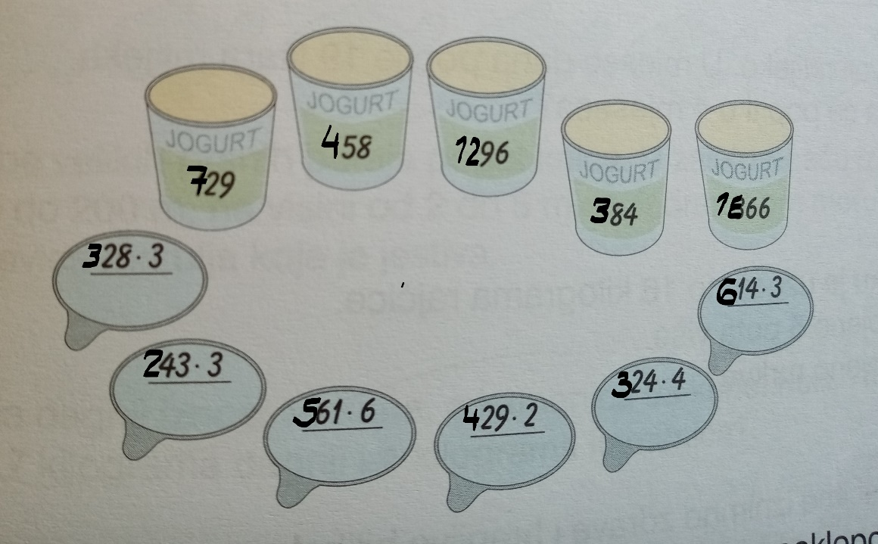

PREPARE (for 1 group) 5 glassess from joghurt and covers.

3. Instead of traffic signs, enter numbers and calculate. In some tasks we have brackets Remember how we solve problems with brackets!

COPY NEXT EXCERCISE
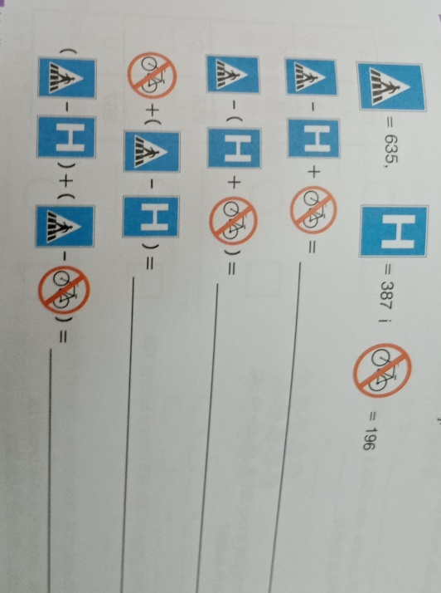

4. What time is it?
We have the clocks drawn in the table. There are times (results) on the table. Your task is to connect the clock and the exact time.
PREPARE THE SUBSTRATE WITH HOURS AND RESULTS (EXACT TIME). CUT THE CURRENT TIMES AND JOIN THE WATCHES

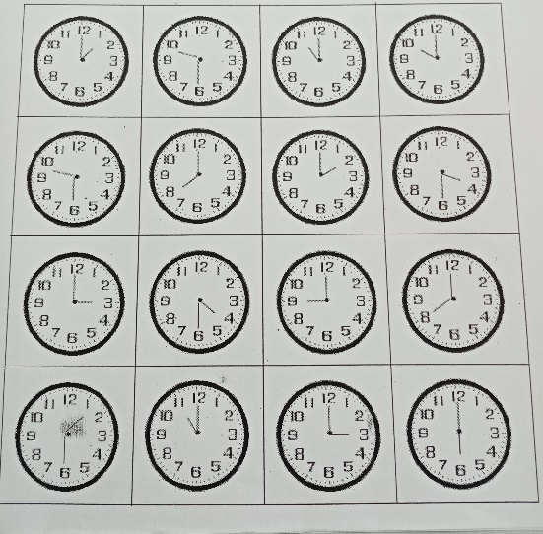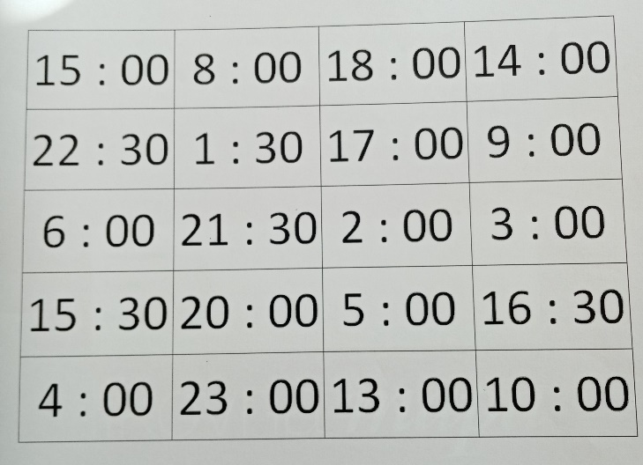

Tangram
Tangram is one of the oldest and most famous puzzles. This mathematical puzzle consists of seven standard parts, of which images of different objects are put together.
CUT PARTS OF THE TANGRAM ACCORDING TO THE EXISTING SHEME.

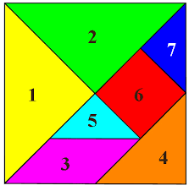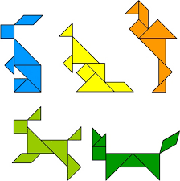
Try to put together one animal figure, shown on the right, of your choice.
https://wordwall.net/resource/12980103/matematika/dijeljenje-brojeva-procijeni-rezultat-4-razred

